LAB -4 JAVA

SHAPES

NAME: AFREEN ANZ

1BM23CS016

Output:

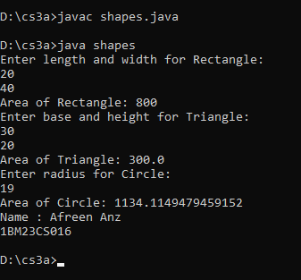

Source Code:

import java.util.Scanner;

abstract class Shape {

int dim1;

int dim2;

public Shape() {

this.dim1 = 0;

this.dim2 = 0;

}

public Shape(int dim1, int dim2) {

this.dim1 = dim1;

this.dim2 = dim2;

}

public abstract void printArea();

}

class Rectangle extends Shape {

public Rectangle(int length, int width) {

dim1 = length;

dim2 = width;

}

public void printArea() {

int area = dim1 \* dim2;

System.out.println("Area of Rectangle: " + area);

}

}

class Triangle extends Shape {

public Triangle(int base, int height) {

dim1 = base;

dim2 = height;

}

public void printArea() {

double area = 0.5 \* dim1 \* dim2;

System.out.println("Area of Triangle: " + area);

}

}

class Circle extends Shape {

public Circle(int radius) {

dim1 = radius;

dim2 = 0;

}

public void printArea() {

double area = Math.PI \* dim1 \* dim1;

System.out.println("Area of Circle: " + area);

}

}

public class shapes {

public static void main(String[] args) {

Scanner in = new Scanner(System.in);

System.out.println("Enter length and width for Rectangle:");

int length = in.nextInt();

int width = in.nextInt();

Shape rectangle = new Rectangle(length, width);

rectangle.printArea();

System.out.println("Enter base and height for Triangle:");

int base = in.nextInt();

int height = in.nextInt();

Shape triangle = new Triangle(base, height);

triangle.printArea();

System.out.println("Enter radius for Circle:");

int radius = in.nextInt();

Shape circle = new Circle(radius);

circle.printArea();

in.close();

System.out.println("Name : Afreen Anz\n1BM23CS016");

}

}